Annex 2

Description of the object

AUCTION: University of Latvia (UL) is launching an official auction of intellectual property's “Clay mineral - anthocyanin composite material sensors for food quality control”.

STATEMENT OF THE INVENTION: consists of know-how, a trade secret and unregistered Community design developed under the non-economic project of the European Regional Development Fund no. KC-PI-2020/11 " Clay mineral - anthocyanin composite material sensors for food quality control (LU registration No. ESS2020/371)".

The description of the know-how, trade secret and unregistered Community design includes new and unpublished freshness indicator development methods, integration variations and design schemes for incorporating the indicator into food product packages in various gas environments. The know-how, trade secret and unregistered Community design contain detailed descriptions, schematics, prototype technical drawings of the indicator casing and package insert.

More detailed information about the invention can be provided by the project manager: Rūta Ozola-Davidāne, ruta.ozola-davidane@lu.lv, and the initial commercialization strategy can be commented on by the project commercialization expert Solvita Kostjukova solvita.kostjukova@gmail.com.
- Price range: according to the offer of the applicant
- Keywords: smart sensors; indicator for detecting pH changes; food quality monitoring
- The research was carried out by: the Faculty of Geography and Earth Sciences of the University of Latvia
- Contact phone: +371 22466559 (Rūta Ozola-Davidāne), +371 26742227 (Solvita Kostjukova)
- Contact e-mail: ruta.ozola-davidane@lu.lv; solvita.kostjukova@gmail.com

SUMMARY:
A prototype of a freshness sensor-indicator has been developed, which can be integrated into standardized food packaging to detect the freshness of the packaged meat product in real-time, thereby reducing meat waste in the food industry.
The basic operating principle of the technology is based on the fact that the freshness indicator indicates changes in the pH of the food and packaging environment caused by bacterial contamination in the process of product deterioration. The developed freshness indicator changes color from red to blue as the food product spoils, thus demonstrating food quality to consumers in a very simple way. Using the developed technology, consumers have the opportunity to make informed decisions about food quality and reduce the amount of food waste.

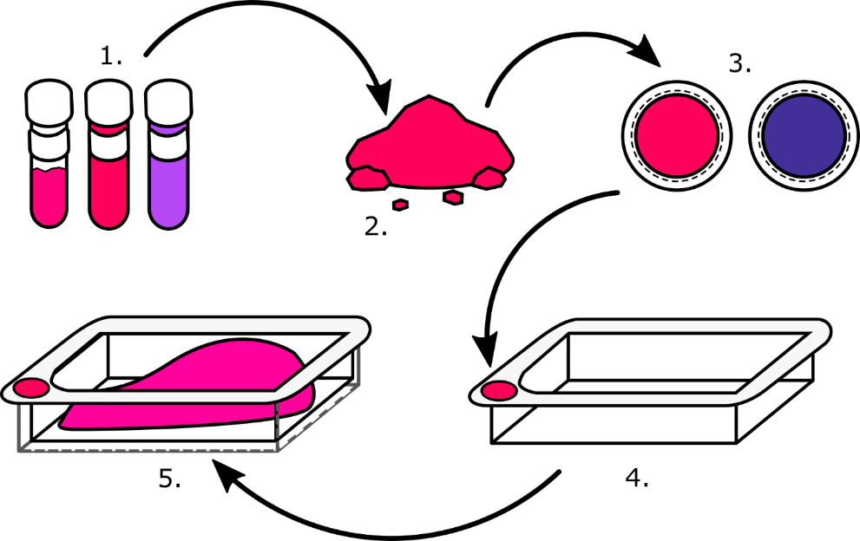

Freshness indicators technology basic principles. 1. Extracted active substances - anthocyanins; 2. Anthocyanins stabilized into clay mineral structure – sensor composition; 3. Freshness indicator pigment applied to the carrier material, indicating red when meat is fresh and blue when meat is spoiled; 4. The insert with an incorporated indicator; 5. Prototype system – the insert is placed in the standard packaging.
Advantages of freshness indicator technology:
1. Food quality monitoring in real-time
2. Ease of sensor performance and perception
3. Ease of incorporation into standard packaging solutions
4. Raw materials without shortage
5. Reusable and high color fastness
6. Nontoxic and biodegradable
7. Can be certified for food contact
Freshness indicator technology video: https://www.youtube.com/watch?v=gYI1EL5DozA

PRODUCT OF THE INVENTION: technology and methodology for the development and integration of freshness indicators in food packages for their quality control.
A brief description of the main components of IP
- Unregistered IP (know-how) and trade secret for freshness indicator pigment.
The main component of the freshness indicator is a pigment that indicates the quality of food products by changing its color. The basic functions of the freshness indicator pigment are as follows:
- The active substances in the pigment composition are natural, non-toxic and biodegradable.
- Color change functionality is determined by anthocyanins (natural pigments), which can be extracted from various fruits and vegetables, as well as their press residues after the juicing process. The second main ingredient is clay materials, which are used as stabilizers to protect anthocyanins from UV radiation and other physicochemical factors that can cause anthocyanin degradation.
- Color change from red to blue when the product is organoleptically and microbiologically unsuitable for consumption;
- Food quality monitoring in real-time;
- The pigment is suitable for use in packaged food products in various gas environments (air, nitrogen, a mixture of nitrogen and carbon dioxide);
- Potentially complements data labels, eliminating the risk of selling products that have been damaged due to inappropriate transport conditions;
- Can be used for food products of animal origin such as fresh meat products, with the potential for use in fish, egg and dairy products;
- Does not change the color, smell or any other properties of the food product, nor does it affect the composition of gases in the packaging environment;
- Can be certified for food contact.

- Unregistered design for a prototype of a food packaging insert for the integration of a freshness indicator. The freshness indicator pigment is applied to the carrier material and can be integrated into the prototype system of the food packaging insert. The basic functions of the food packaging insert prototype are as follows:
- The shape of the insert is adapted for easy insertion of the freshness indicator;
- The shape of the package insert ensures the collection of moisture released by the product;
- Can be used for standardized packages of food products (meat), which are packaged in gas environments (air, nitrogen, a mixture of nitrogen and carbon dioxide);
- Made from materials that are certified for food contact.

- Unregistered design for freshness indicator casing. The freshness indicator pigment is applied to the carrier material and can be integrated into food packages with indicator casing that is placed on the surface of the product. The basic functions of the freshness indicator casing are as follows:
- The shape of the case is adapted for easy insertion and fixing of the freshness indicator on the surface of the food product;
- Can be used for all types of food products (meat) packages, which are packaged in gas environments (air, nitrogen, a mixture of nitrogen and carbon dioxide).
INDUSTRY:
The invention refers to smart packaging solutions in the food industry, especially to indicators that directly indicate the deterioration of the quality of perishable food products caused by the presence of unwanted microorganisms or chemical changes in the packaging environment.
PURPOSE AND NATURE OF THE INVENTION:
The purpose of the invention is to significantly improve real-time food quality control/safety so that is easy for food consumers/producers to understand and reduce food waste associated with food product date labels.
Disadvantages of other equivalent technologies:
- low diversity of integration in food packaging (Oscillum);
- uses synthetic dyes (Insignia Technologies);
- the indicator is not reusable (Insignia Technologies, Oscillum, Food Quality Sensor Intl. (FQSI)).
Common features with other technologies:
- application to different groups of food products (Oscillum, Insignia Technologies, Food Quality Sensor Intl. (FQSI));
- technology is not commercialized (Oscillum, Food Quality Sensor Intl. (FQSI)).

PROTECTION OF INTELLECTUAL PROPERTY:
Know-how, trade secret and unregistered Community design are written descriptions that include new and unpublished methods of development of freshness indicators, integration variations and design schemes for incorporating the indicator into food product packages in various gas environments. The know-how, trade secret and unregistered Community design contain detailed descriptions, schematics, prototype technical drawings of the indicator casing and package insert.

OTHER INFORMATION:
The technology of freshness indicators has been validated with the products of SIA “RIMI Latvija”, AS “Putnu fabrika Ķekava”, SIA “Māras brieži” and SIA “Gaļas pārstrādes uzņēmums Nākotne”.

INTELLECTUAL PROPERTY DOCUMENTATION:
Additional documentation can be obtained by signing a confidentiality agreement with the University of Latvia.

