Annex 2

DESCRIPTION OF THE OBJECT

AUCTION:
The licensing or sale of intellectual property resulting from studies at the University of Latvia (LU) shall take place in accordance with Section 39.5 of the Law on Scientific Activities.
LU is announcing a written auction of intellectual property “A device and a method for detection of gastric cancer through exhaled breath in a test subject”.

STATEMENT OF THE INVENTION:

Object of auction -– the right to intellectual property – the invention “A device and a method for detection of gastric cancer through exhaled breath in a test subject”, according to the International Patent Application No. PCT/LV2021/050006 “A DEVICE AND A METHOD FOR DETECTION OF GASTRIC CANCER THROUGH EXHALED BREATH IN A TEST SUBJECT” (“Intellectual Property”).

More detailed information on the invention and the original commercialization strategy can be provided by the project manager: Marcis Leja, marcis.leja@lu.lv.
- Bid range: per bidder's offer
- Keywords: gastric cancer, volatile organic compounds, sensors
- The study was conducted by: Institute of Clinical and Preventive Medicine of the University of Latvia
- Phone number of the contact person: +371 286 551 58 (Ilmars Stonāns)
- E-mail of the contact person: ilmars.stonans@lu.lv

The Intellectual property was created within the Activity 1.2.1.2 "Support for the Improvement of Technology Transfer System" of the Specific Objective 1.2.1 "To increase investments of private sector in R&D" of the Operational Programme "Growth and Employment" KC-PI-2017/75 “Volatile Marker Breath Analyser for Gastric Cancer Screening”.

Brief description of the invention “A DEVICE AND A METHOD FOR DETECTION OF GASTRIC CANCER THROUGH EXHALED BREATH IN A TEST SUBJECT”
(forward - invention)

PRODUCT OF THE INVENTION: a description of a proprietary “Device and a method for detection of gastric cancer through exhaled breath in a test subject”.

SUMMARY:
The invention is to be used for gastric cancer screening by applying combined detection of volatile markers with a device containing an optimized set of different types of breath sensors and a method characterized by an optimized sensor signal evaluation algorithm. The device includes: (a) a set of sensors consisting of sensors responding to the presence of volatile organic compounds in the exhaled breath of a test subject; (b) a processing unit comprising a sample recognition analyser; and (c) a memory connected to the processing unit. An algorithm was created that uses the best (reducing class entropy) sensors. As a result, the sensor set required for breath analysis consists of two type X sensors (TX2 and TX5), two type Y sensors (TY5 and TY8). The developed algorithm is highly sensitive and specific, distinguishing the breath of healthy people from cancer patients, and uses only four sensors and relatively few calculations (requiring little computing resources). The sensitivity and specificity of this algorithm are 73,9% and 84,3%, respectively. Thus, the proposed algorithm reduces the required number of sensors and calculations, demonstrating high specificity and sensitivity.
INDUSTRY: This invention is related to the clinical medical industry, particularly gastric cancer screening using combined detection of volatile markers with different types of breath sensors.

PURPOSE AND NATURE OF THE INVENTION:
The invention aims to provide an improved system and process for detecting gastric cancer in exhaled breath. This is achieved by using a device to detect gastric cancer in the air exhaled by a test subject, which includes: (a) a set of sensors consisting of sensors that respond to the presence of volatile organic compounds in the air exhaled by a test subject; (b) a processing unit that includes a sample recognition analyser; and (c) a memory connected to the processing unit. The sample recognition analyser is configured to receive the output signals of the sensor set, compare them with gastric-cancer-specific samples derived from the data base of samples of sensor set responses to exhalations of gastric cancer patients, and select the closest match between the output signals of the sensor set and the specific gastric cancer sample. The sensor set consists of two type X sensors (TX2 and TX5), type Y sensor (TY5) and type Y sensor (TY8). There are instructions stored in the memory, which, when the processing unit is executing them, tell the processing unit: (i) to calculate the mean of the normalized values of the predefined last data points of type X sensor (TX2); if this value is less than or equal to the previously stated value, go to step ii, otherwise go to step iii; ii) to calculate the minimum value of the normalized value of the type X sensor (TX5); if the value is less than or equal to a predefined value, output a signal that the breath is characteristic for gastric cancer; otherwise, signal that no stomach cancer has been detected; iii) to find the maximum value of the normalized value of type Y sensor (TY5); if the value is less than or equal to the predefined value, output a signal that the breath is typical to gastric cancer; otherwise, go to step iv; (iv) calculate the mean of the normalized values of the predefined last data points of type Y type sensor (TY8), if the value is less than or equal to the predefined number, go to step v, otherwise signal that gastric cancer has not been detected; v) find the minimum value of the normalized values of the type X sensor (TX5); if the value is less than or equal to the predefined value, signal that gastric cancer has not been detected; otherwise, output a signal that breath is characteristic for gastric cancer.
In practice, the target is achieved using the method to detect gastric cancer in the air exhaled by a test subject, and this method includes: (a) guiding the exhaled air of the test subject to a sensor set that responds to the presence of volatile organic compounds, and the sensor set includes: two type X sensors (TX2 and TX5), type Y sensor (TY5) and type Y sensor (TY8); (b) receiving output signals of the sensor set from a processing unit that includes a sample recognition analyser; (c) compare output signals to specific samples derived from the data base of samples of sensor set responses to exhalations of individuals affected by gastric cancer, and select the closest match between the sensor set output signals and the specific sample, the operation referred to in step c shall consist of the following: i) calculating the mean value of the predefined number of normalized final data points for the type X sensor (TX2); if this value is less than or equal to the predefined value, go to step ii, otherwise go to step iii; ii) determine the minimum value of the normalized values of the type X sensor (TX5); if the value is less than or equal to a predefined value, output a signal by notifying the user (via the display attached to the processing unit) that the breath is typical of gastric cancer; otherwise, output a signal by notifying the user that no gastric cancer has been detected; iii) find the maximum value of the normalized values of the type Y sensor (TY5); if the value is less than or equal to a predefined value, output a signal by notifying the user that the breath is typical for gastric cancer; otherwise go to step iv; iv) calculate the mean value of the normalized values of the predefined number of last data points of the type Y sensor (TY8), if the value is less than or equal to a predefined value, go to step v, otherwise, output a signal by notifying the user that no gastric cancer has been detected; v) find the minimum value of the normalized values of type X sensor (TX5); if the value is less than or equal to a predefined value, output a signal by notifying the user that no stomach cancer has been detected; otherwise, output a signal by notifying the user that the breath is typical for gastric cancer.
The implementation of the invention is shown in the following figures:
Figure 1 - is a flowchart that shows the nature of the invented method.
Calculate the average of the last 10 data points of the normalized TX2 value (x1)
X₁≤ 0,999712
Find the minimum value of the normalized TX5 value (x₂)
X₂≤ 1,012935
Find the maximum value of the normalized TY5 value (x3)
X₃≤ 0,915563
Cancer specific
Specific for healthy subjects
Calculate the average of the last 10 data points of the normalized TY8 value (x₄)
Cancer specific
X₄≤ 1,000036
Specific for healthy subjects
Find the minimum value of the normalized TX5 value (x₅)
X₅≤ 1,010648
Specific for healthy subjects
Cancer specific
True
True
True
True
True
False
False
False
False
False

Figure 2 - Schematic representation of the proposed device
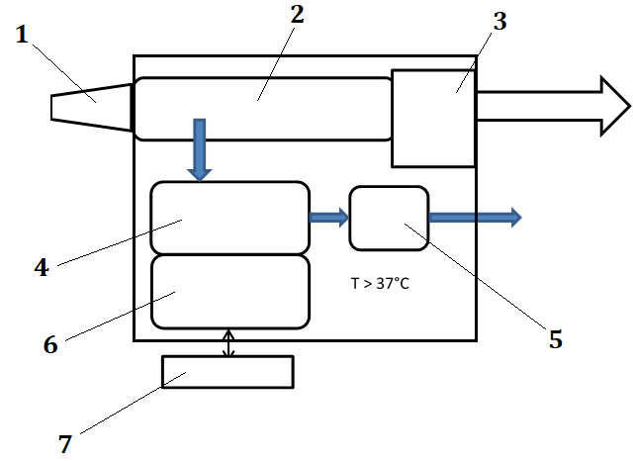
The device also consists of a disposable mouthpiece (1) connected in the gas stream to a sampling tube (2), which is connected in the gas stream to a flow, humidity and CO2 sensor unit (3); the sampling tube has a side flow branch connected to the sensor chamber (4) in the gas flow to the pump (5); the sensor chamber (4) is connected to a processing unit (6) connected to the display (7). Sensor chamber (4) is made up of a set of sensors that respond to the presence of volatile organic compounds in the exhaled air of the test subject.
Figure 3 - Measurement process chart
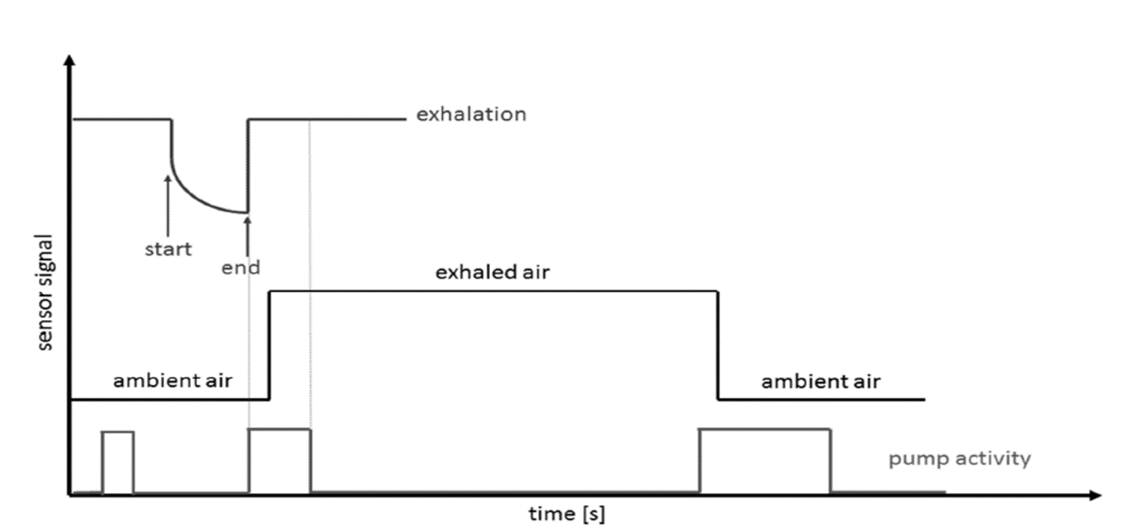

PROTECTION OF INTELLECTUAL PROPERTY:
International patent application No. PCT/LV2021/050006 “A DEVICE AND A METHOD FOR DETECTION OF GASTRIC CANCER THROUGH EXHALED BREATH IN A TEST SUBJECT”.

INTELLECTUAL PROPERTY DOCUMENTATION, which includes:
1. Rights of use of patent applications

